Project Report
Project Title
Harsh Chauhan -- S24CSEU0745
Akash Sharma – S24CSEU0625

A report submitted in part fulfilment of the degree of
BTech in Computer Science
Supervisor: Susmita Das

School of Computer Science Engineering and Technology

Date – 12-11-2025

Abstract

- Introduction

- Proposed Works/Methodology

- Data structure and algorithms used.

- Result Analysis

- Conclusion

Introduction

Stock market forecasting has always been a challenging yet crucial problem in financial analysis. Bank stocks, in particular, exhibit patterns influenced by economic indicators, monetary policies, and investor sentiment.

Stock price prediction is a classic and important problem. As there are many stock buyers who exactly don’t know about the stocks, they just purchased stocks considering it will provide higher returns.

The BankScan Analytics project was developed to create an simple full-stack application that is capable of predicting future bank stock prices using data-driven approaches.

The goal of our project is to provide insights into stock price trends and predict the future prices of stocks for the specific day, next 30 days and for a year long. Our model uses simply HTML, CSS and JavaScript for smooth user interface and visualize historical data and future predictions on an interactive chart.

Proposed Works/Methodology

The workflow of BankScan Analytics consists of several key stages:
- Data Collection and Preprocessing:
Historical stock data of various banks (e.g., SBI, HDFC, ICICI, Axis Bank, etc.) are stored in CSV format inside the data/ directory.
The load_and_clean_data() function is used to clean and prepare the data by handling missing values and formatting dates.
- Feature Engineering:
Using the create_date_features() method, multiple temporal attributes are derived from the “Date” column — such as day, month, quarter, week, and whether the date falls on a weekend or weekday.
This process helps the model learn seasonal and periodic patterns in bank stock prices.
- Model Training: For different banks, I trained a machine learning model using random forest regressor. Basically, the data of each bank was given to this model to learn how the stock prices changes with time
4. API Development:
API request and response bodies between the client and the FastAPI server
5.Prediction Workflow:
> The requested date range is generated dynamically.
> Features are computed for each date, the trained model predicts closing prices for the given period
> The output includes both the predicted trend and the exact value for the target date.
Data structure and algorithms used

Data Structures
> JSON: It is basically used for the non-ML parts in the project. It is basically used to store:
-> Static data for the frontend
->API request and response bodies between the client and the FastAPI server.

- NumPy Arrays: Used internally for numerical computation and model input preparation.

- Pandas DataFrames: Dataframes are the main structure that we are for data cleaning, preprocessing, feature engineering and model training.

Algorithms
- Random Forest Regressor:
- It is an ensemble-based supervised learning algorithm that combines multiple decision trees.
- It captures non-linear relationships between time-based features and closing prices.
- It offers robustness against overfitting and provides stable predictions even with noisy stock data.
- Matplotlib : It is used for Data visualization
- Scikit Learn : It is used for Machine learning utilities

Result Analysis

After training and testing the models on individual bank datasets that I included in my project, the Random Forest Regressor achieved good performance in predicting daily, monthly and yearly stock trends.
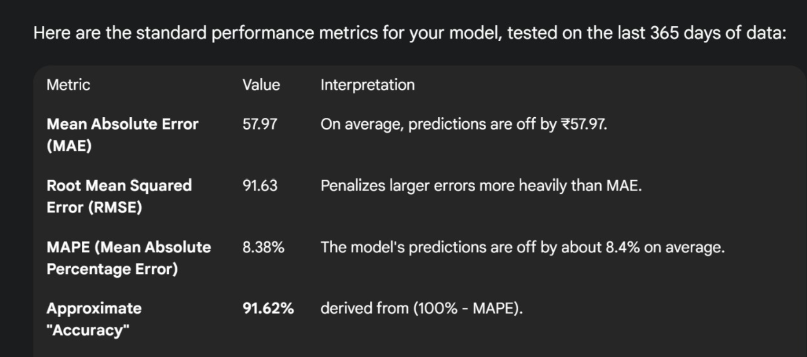

CONCLUSION

Our BankScan Analytics project successfully helps users to invest in right stocks of bank when the stock prices are low and ready to invest.
The Random Forest Regressor’s ensemble approach effectively handles noisy financial data, while FastAPI ensures real-time responses with low latency.

Future work we are planning is:
We will use deep learning models like LSTMS or ARIMA for higher accuracy.
We will add more company stocks, mutual fund stocks etc. so that our project not only remain to predict stock prices of banks.

